[**VISUAL PHYSICS ONLINE**](http://www.physics.usyd.edu.au/teach_res/hsp/sp/spHome.htm)

**MODULE 7 NATURE OF LIGHT**

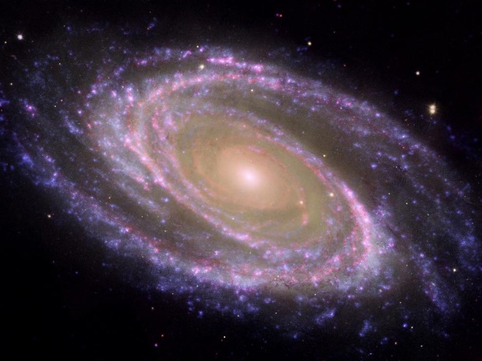

**ELECTROMAGNETIC WAVES**

**ELECTROMAGNETIC SPECTRUM**

When white light passes through a prism, it spreads out into a rainbow of colours, with red at one end and violet at the other. Each colour corresponds to an electromagnetic wave with a unique frequency (or wavelength).



This range of wavelength from 700 nm to 400 nm is known as **visible light** since our eyes are only sensitive to electromagnetic waves in this range.

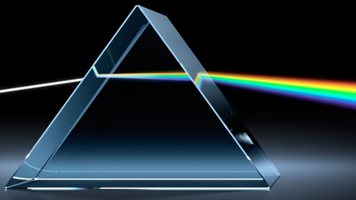

The full range of wavelengths (or frequencies) is known as the **electromagnetic spectrum**. In a vacuum, all electromagnetic waves have the same speed, the speed of light such that



Certain bands of the spectrum are given special names.



[VISUAL PHYSICS ONLINE](http://www.physics.usyd.edu.au/teach_res/hsp/sp/spHome.htm)

If you have any feedback, comments, suggestions, links or corrections please email:

Ian Cooper School of Physics University of Sydney

ian.cooper@sydney.edu.au

Fig. 1. The electromagnetic spectrum and the band for visible light.

**Radio Waves** 

The lowest frequency (longest wavelength) band of electromagnetic waves that are useful are called radio waves.

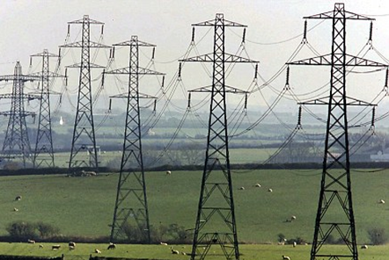

Radiation is emitted from power lines



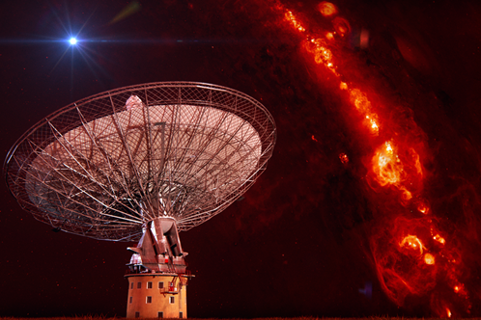Accelerated charged molecules and atoms in outer space emit radio waves which are detected on Earth using large radio telescopes.

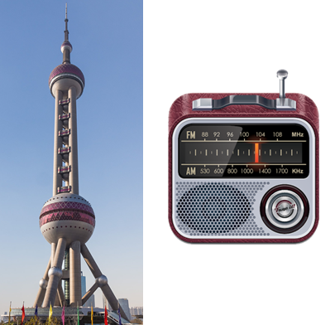

Radio waves are used in communication in radios and in televisions. The radio waves are generated by alternating currents in metal antennas and detected by the induced currents in metal aerials.

**Microwaves Waves**



Microwaves are the highest frequency electromagnetic waves that can be produced by electronic circuits.

Microwaves are used for communications in mobile phones and for communication with satellites.

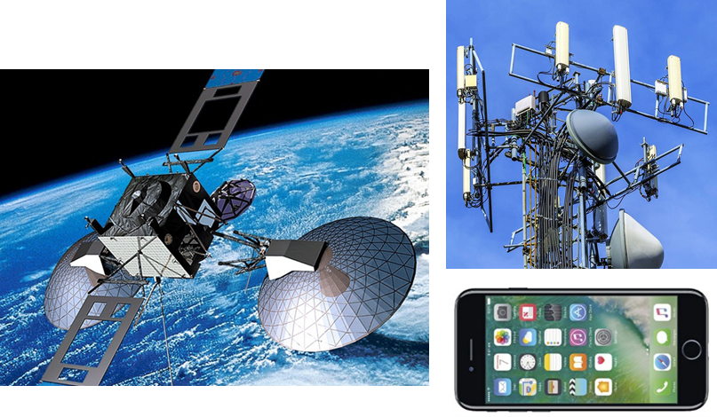



Microwaves are used for heating purposes such as in microwave ovens to heat water.

**Infrared (IR) Waves**



Why do you get warm standing in the Sun?

Infrared waves are often generated by the rotation and vibration of molecules. When infrared waves are absorbed by an object, its molecules rotate and vibrate more vigorously resulting in an increase in temperature of the object.



Photographs made with infrared are often called **thermograms**. Thermograms provide a useful remote sensing technique for measuring temperate. Thermograms use used routinely in detecting cancers and tumours.

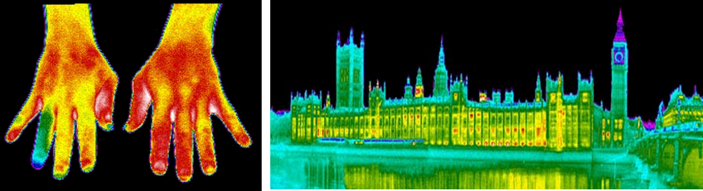

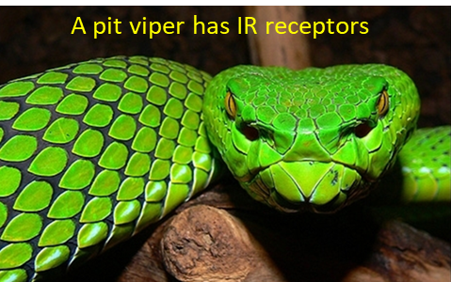Some animals have specialized infrared sensors that allow them to “see” the infrared waves given-off by warm blooded prey.



Many remote controls used with TVs, DVD players, air conditioning units use an IR beam.

**Visible light**



Our eyes are sensitive only to the narrow band within the electromagnetic spectrum called visible light. Each of the colours we perceive by our eyes and nervous system is the response to electromagnetic waves of different frequencies. White light is a mixture of all colours of visible spectrum. The millions of colours displayed in a TV picture is the result of mixing different proportions of red, blue and green light.

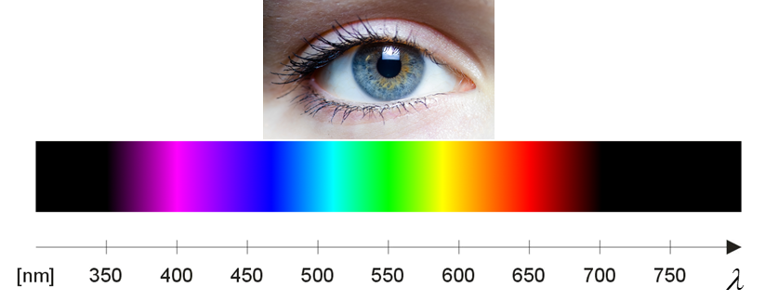

Visible light is produced when outer electrons in a higher energy levels drop to lower energy levels. The spacing between the two energy levels in the transition determines the colour (frequency) of the light.

**Ultraviolet (UV) light**



UV radiation can have harmful effects on the skin and long exposure can increase the risk of developing skin cancers. Fortunately, most UV radiation that reaches the Earth from the Sun is absorbed by ozone O3 molecules in the upper atmosphere.

UV photons are very energetic can ionize some molecules and disrupt chemical bonds. UV radiation can cause eye damage. Because of the high energy of UV photons, UV light is sometimes used for sterilization purposes.

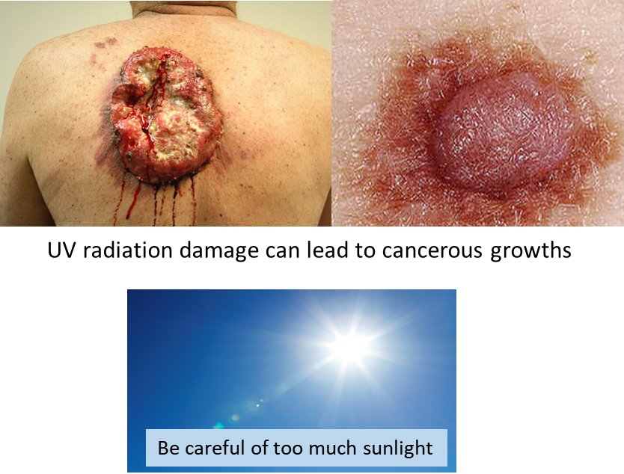

UV radiation is due to transitions of electrons in atoms “moving” from higher energy levels to lower energy levels, the spacing between the energy levels is greater than those for visible light.

Some bees and butterflies can see in the UV band.

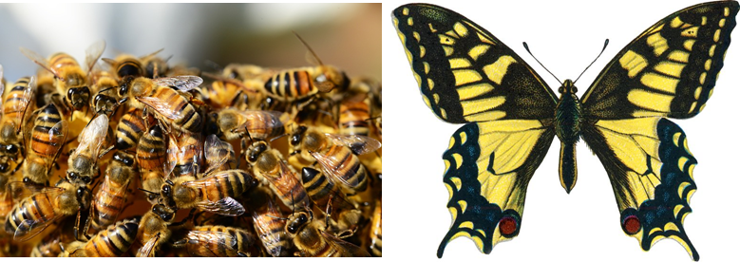

**X-rays**



X-rays are used to create X-ray images of objects. The use of X-ray images is a very important diagnostic tool used in medicine by doctors. These energetic rays are only weakly absorbed by our skin and soft tissue and mainly pass through our bodies, but when they encounter our bones or teeth or other relative dense material they are more strongly absorbed. X-rays do cause damage to our cells and tissues, so, it is best to reduce your exposure to them.

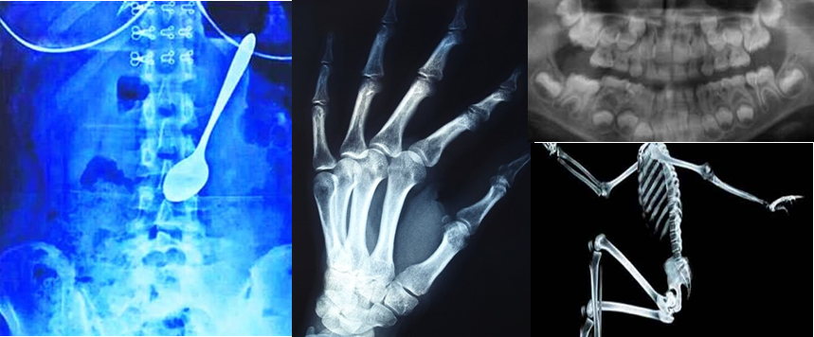

Electrons are accelerated to very high speeds and then smashed into a metal target to produce X-rays.

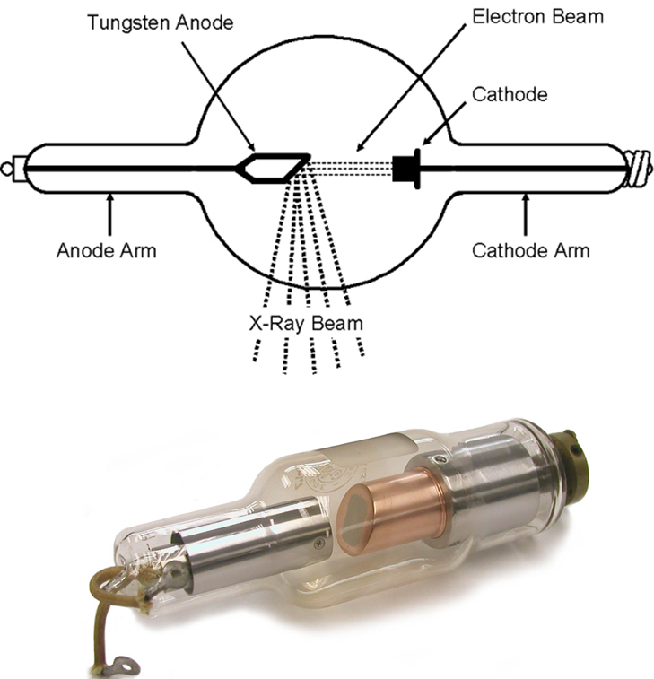

X-rays which are highly energetic and ionizing radiation are emitted from atoms when there are large differences in the initial and final energy levels.

**Gamma rays** 



Generally, the energy of gamma rays are even more energetic than X-rays. **Gamma rays** are emitted from a **nucleus** of an atom. During radioactive processes, radioactive nuclei are left in an excited state, and then lose energy by the emission of a gamma ray photon. When there is an annihilation between matter and antimatter, gamma rays are produced.

Gamma rays are highly penetrating and destructive to living cells. It is reason they are used in cancer treatment to kill cancerous cells. Unfortunately, as well as destroying cancer cells, healthy cells are also killed.

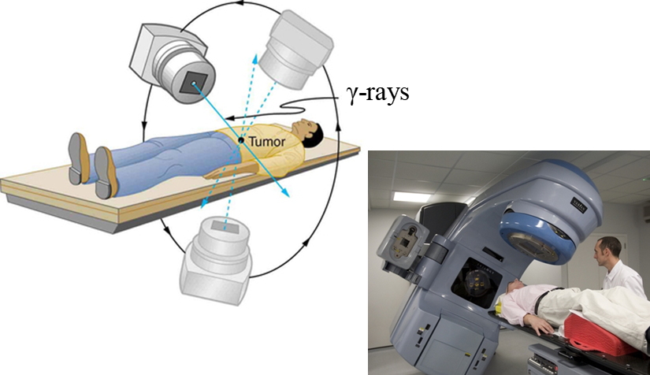



Large quantities of gamma rays are emitted in an atomic bomb explosion.

[VISUAL PHYSICS ONLINE](http://www.physics.usyd.edu.au/teach_res/hsp/sp/spHome.htm)

If you have any feedback, comments, suggestions, links or corrections please email:

Ian Cooper School of Physics University of Sydney

ian.cooper@sydney.edu.au